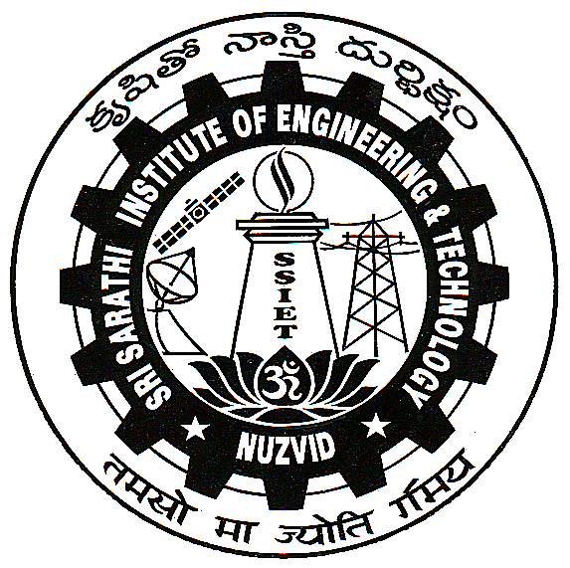 | E-mail: ssiet.54@gmail.com Established: 1998 Office: 08656-233711,235711  Website: ssiet.edu.in Principal: 08656-234001  Sri Sarathi Institute of Engineering & Technology  Dr.No.2-78-10A, Near MDO Office, Nuzvid – 521 201. Krishna Dist. A.P.  (Approved by AICTE – Affiliated to JNTUK) (Sponsored by : SEVA TRUST, Hyderabad.)

REGISTRATION / APPLICATION FOR ADMISSION INTO B. TECH.
UNDER CATEGORY ‘B’ (MANAGEMENT QUOTA) FOR 2017-18

Affix recent passport size photograph duly attested by the employer with Office Seal
- Name (in block letters as per SSC)______________________________
- Father/Guardian Name_______________________________________
- Mother’s Name______________________________________________
- Date of Birth (As per SSC)_____________________________________
- Gender: Male / Female.
- Nationality: _____________ 7. Religion ___________
- INDICATE CATEGORY BY PUTTING TICK MARK IN THE APPROPRIATE BOX:
OC | BC-A | BC-B | BC-C | BC-D | BC-E | S C | S T | OBC | MINORITY

- DETAILS OF QUALIFYING EXAMINATIONS:
Qualifying Examination | Institution | Board / University | Year of  Passing | Marks Obtained/ Percentage
10th Class
Inter/CBSE
Diploma
Degree
Any Other

- EAMCET/ECET/ICET Hall Ticket No.__________________ Rank___________________
- ADDRESS FOR CORRESPONDENCE:
Present Address | Permanent Address
_____________________________________  ____________________________________  ____________________________________  _________________Pin No.:____________  Parent/Guardian Mobile No._____________  Landline No._________________________  E-mail ID: | _____________________________________  ____________________________________  ____________________________________  _________________Pin No.:____________  Parent/Guardian Mobile No._________  Landline No._____________________  E-mail ID:
- Branch Applied for:

Sl.  No. | Course |  | Tick mark in the  appropriate box:
1 | B. Tech. (Electrical & Electronics Engineering) | E E E
2 | B. Tech. (Electronics & Communication Engineering) | E C E
3 | B. Tech. (Computer Science & Engineering) | C S E
4 | B. Tech. (Mechanical Engineering) | MEC

- Documents to be Submitted in originals at the time of admission :
- 10th / SSC Certificate
- 12th / Intermediate Certificate
- Study Certificate (VIth Class to Xth Class)
- Intermediate Study Certificate
- Intermediate Transfer Certificate
- EAMCET Hall Ticket and RANK Card

- DECLARATION:

- I will not approach the competent authority for cancellation / refund of fee / transfer etc. under any
circumstances after the fee is paid.

- Either myself or my son/daughter will not approach the college authorities for the return of the Original
Certificates which I submitted at the time of my joining till my ward till completion of the 4/3 years
course.

- Either myself or my son/daughter will not attend the counseling for admission, since I have agreed to
admit my son/daughter in your college under Management/NRI Quota.
iv. My ward will abide by the rules & regulations of the college till he/she complete the course.

I undertake to that the information furnished is true to the best of my knowledge and belief. I also acknowledge that mere applying for admission doesn’t entitle me for any claim of admission. Further, if admitted under “B” category the same shall be deemed to be confirmed admission only upon receiving ratification from statutory bodies like APSCHE/JNTUK, Kakinada / State Technical Board.

Signature of the Student Signature of the Parent/Guardian

Name: Name
Date: Date:
FOR OFFICE USE ONLY
Admitted
Not Admitted

Verified by
Administrative Officer Signature of the Principal

GENERAL INFORMATION:

Separate application is to submitted for each branch.

A D.D. for Rs.500/- per application should be drawn in favour of the Principal, Sri Sarathi Institute of Engineering and Technology, Nuzvid -521201, Krishna Dist. towards application and registration fee.

The duly filled application along with the D.D. and enclosures should reach the Principal, Sri Sarathi Institute of Engineering and Technology, Nuzvid 521201, Krishna Dist. on or before 20-07-2017.

Online submission of application along with the scanned copies of enclosures may be sent through e-mail to: ssiet.54@gmail.com, the hard copy of the application such candidates along with the D.D. should reach the Principal, Sri Sarathi Institute of Engineering and Technology, Nuzvid -521201, Krishna Dist. on or before 20-07-2017. The college is not responsible for any postal delay.

ALLOTMENT OF SEATS:
As per the guidelines issued by the A.P. State Council of Higher Education, Hyderabad.

NUMBER OF VACANCIES:

Sl.  No. | Course | Intake | B-Category Seats
1 | B. Tech. Electrical & Electronics Engineering (EEE) | 60 | 18
2 | B. Tech. Electronics & Communication Engineering (ECE) | 120 | 36
3 | B. Tech. Computer Science & Engineering (CSE) | 90 | 27
4 | B. Tech. Mechanical Engineering (MEC) | 120 | 36

FEE: Tution Fee for B. Tech. course is Rs.55,000/- per annum.

SCHEDULE OF ADMISSIONS:
- Date of Notification: 22-06-2017
- Last date for Sale of Applications: 23-06-2017
- Last date for submission of application: 20-07-2017 by 5.00 P.M.
- Date of Announcement of Merit List: 20-07-2017
- Admission as per the merit list displayed: 05-08-2017
HOSTEL: Separate hostels are available in the campus for boys & girls.
TRANSPORTATION:
College transport is available from Vijayawada, Gannavaram, Gudiwada, Chatrai, Reddygudem, Lopudi and in Tiruvuru, Ibrahimpatnam & around of Nuzvid town.

